**CDAC MUMBAI**

Concepts of Operating System

**Assignment 1**

**Name: Swati Ashok Jadhav  
Form Number: 241204235  
  
a) Navigate and List:**

**a. Start by navigating to your home directory and list its contents. Then, move into a**

**directory named "LinuxAssignment" if it exists; otherwise, create it.**

Step 1: Entered into my home directory

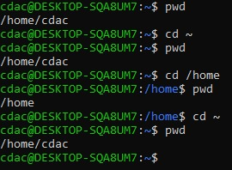

Step 2: Listing my home directory contains:

Step 3: Creating new directory as it was not present:

**b) File Management:**

**a. Inside the "LinuxAssignment" directory, create a new file named "file1.txt". Display its**

**contents.**

**c) Directory Management:**

**a. Create a new directory named "docs" inside the "LinuxAssignment" directory.**

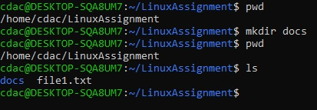

**d) Copy and Move Files:**

**a. Copy the "file1.txt" file into the "docs" directory and rename it to "file2.txt".**First I did this way:

Second I did this way:  
  
Third way:

**e) Permissions and Ownership:**

**a. Change the permissions of "file2.txt" to allow read, write, and execute permissions for**

**the owner and only read permissions for others. Then, change the owner of "file2.txt" to**

**the current user.**

Step 1:

Step 2: The owner of file2.txt is already cdac

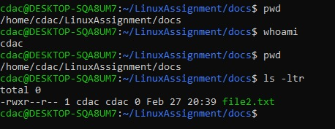

**f) Final Checklist:**

**a. Finally, list the contents of the "LinuxAssignment" directory and the root directory to**

**ensure that all operations were performed correctly.**

**g) File Searching:**

a. Search for all files with the extension ".txt" in the current directory and its subdirectories.

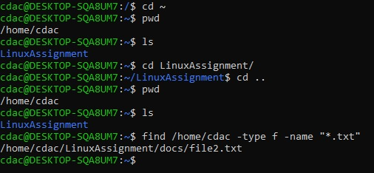

b. Display lines containing a specific word in a file (provide a file name and the specific

word to search).

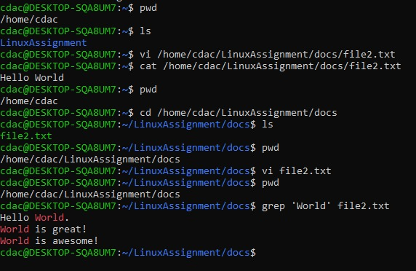

**h) System Information:**

**a. Display the current system date and time.**

**i) Networking:**

**a. Display the IP address of the system.**

**b. Ping a remote server to check connectivity (provide a remote server address to ping).**

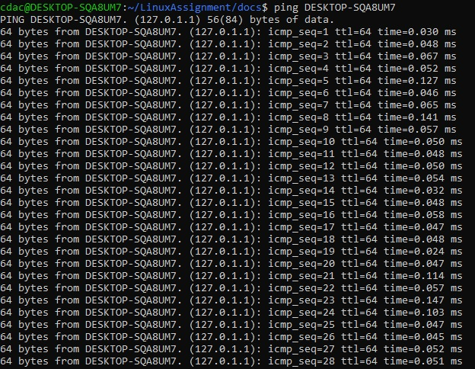



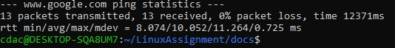

**j) File Compression:**

**a. Compress the "docs" directory into a zip file.**

**b. Extract the contents of the zip file into a new directory.**

**k) File Editing:**

**a. Open the "file1.txt" file in a text editor and add some text to it.**

**b. Replace a specific word in the "file1.txt" file with another word (provide the original**

**word and the word to replace it with).**

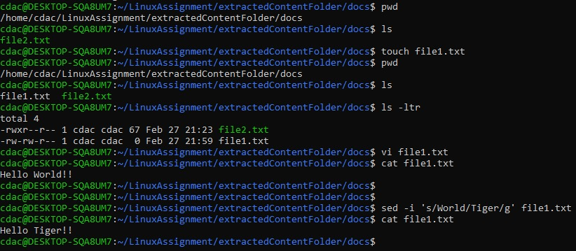

**Problem 2: Read the instructions carefully and answer accordingly. If there is**

**any need to insert some data then do that as well.**

**a. Suppose you have a file named "data.txt" containing important information. Display the**

**first 10 lines of this file to quickly glance at its contents using a command.**

**b. Now, to check the end of the file for any recent additions, display the last 5 lines of**

**"data.txt" using another command.**

*I have empty space at the end of the file.*

**c. In a file named "numbers.txt," there are a series of numbers. Display the first 15 lines of**

**this file to analyze the initial data set.**

**d. To focus on the last few numbers of the dataset, display the last 3 lines of "numbers.txt".**

*I have empty space at the end of the file.*



**e. Imagine you have a file named "input.txt" with text content. Use a command to translate**

**all lowercase letters to uppercase in "input.txt" and save the modified text in a new file**

**named "output.txt."**

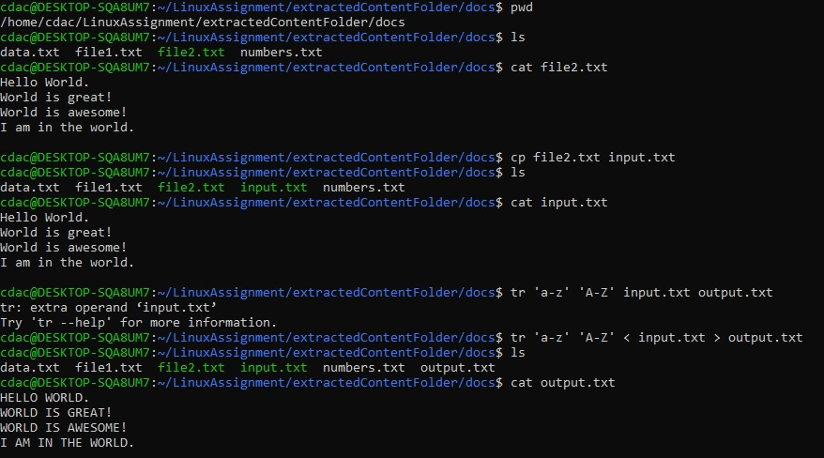

**f. In a file named "duplicate.txt," there are several lines of text, some of which are**

**duplicates. Use a command to display only the unique lines from "duplicate.txt."**

**g. In a file named "fruit.txt," there is a list of fruits, but some fruits are repeated. Use a**

**command to display each unique fruit along with the count of its occurrences in**

**"fruit.txt."**



